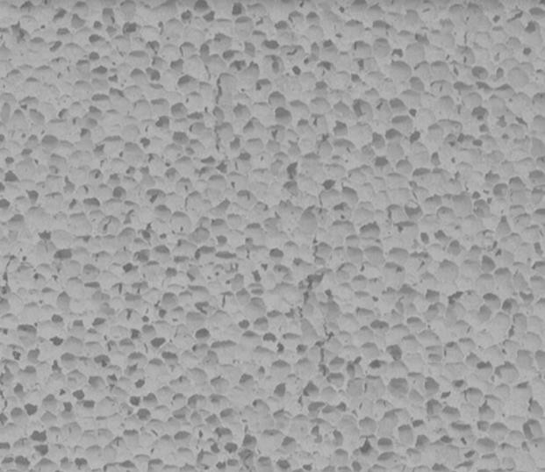
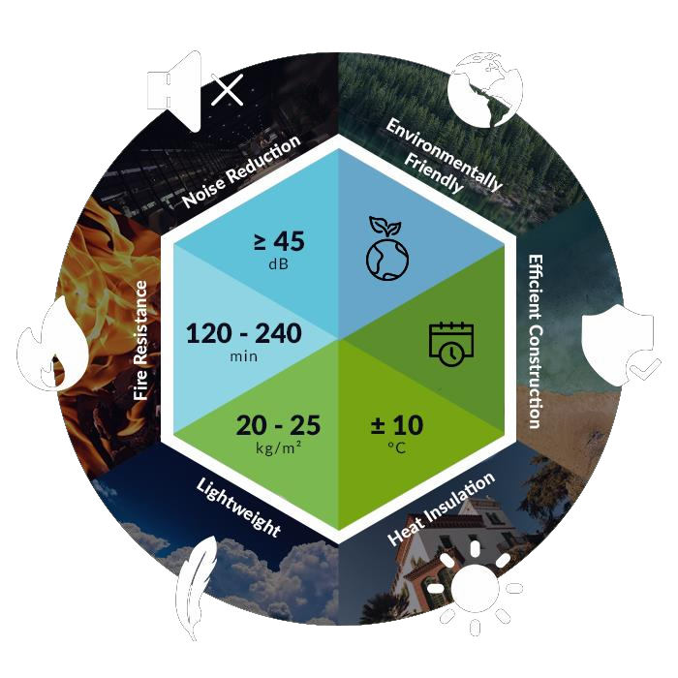

Installation Guide

for AH Lightweight Insulation Block – AH BlockTM

Contents
- Introduction 1
- Benefits 1
- General 2
- System Components 3
- Construction Notes 5
- Construction (Typical) 6
  - Preparatory Works 6
  - AH Block™ System Installation Method 10
  - Fixing Items to Drywall 22
  - Wall Detailing (Typical) 23
Appendix 1 – 92mm AH Block™ Wall System (Typical) 30

Introduction
ISOTEC HOLDINGS Pte Ltd (ISOTEC) owned and committed to be an advocate for the advancement of the circular economy model in Singapore and beyond, not just in words but in action, and to help our society in actualising sustainable economic growth and achieving the best of the circular model. At ISOTEC, we pride ourselves on supplying high quality products that are the result of the circular model. We are committed to maintaining the highest standard of services by ensuring your experience with us is both easy and enjoyable.

The well-developed AH Lightweight Insulation Block (AH Block ™) has an easy to build galvanised steel framework system. AH Block system can be used for non-loadbearing walls in residential, commercial buildings, schools, hospitals, laboratories, warehouses and the like. We supply to both domestic and international markets, particularly in the South East Asia region.

AH Block™ is made in Taiwan, from recycled LCD glass and does not contain any toxic by- products, such as asbestos or formaldehyde. It is a high quality, environmentally-friendly product. It is certified non-combustible, it has attained independent assurance of technical competence for acoustic insulation, thermal insulation, fire resistance, and has a certificate of product conformity in Australia, Singapore and Taiwan.

This product has undergone rigorous laboratory testing, and its performance is on -par, if not superior, to all other similar products that are currently available in the Singapore market. AH Block™ is lightweight, easy to build, and 100% recyclable.

Benefits

Fire Resistance
AH Block non-loadbearing wall system is superior for its fire-resistant performance and is non- combustible. The 92mm AH Block has been tested and proven to achieve Fire Resistance Levels (FRLs) of over 240 minutes, exceeding all other similar building products that are currently on the Singapore market, making it a product of a brighter future.

Noise Reduction
The BCA minimum noise reduction index requirement for walls between adjoining dwellings is 45 dB and 92mm AH Block system exceeded that requirement. It also reduces noise transmission from external source such as vehicle noise, providing a peaceful and comfortable living and working environment.

Environmental Protection and Waste Recycling
The main component of AH Block is made from recycled LCD glass, where it goes through a rigorous recycling process to achieve a high-quality product. It can be 100% reused with minimal raw materials sourced from the natural environment. This process has significant lower environmental impact and produces less greenhouse emissions compared to concrete or brick, making it a truly sustainable building product.

Lightweight and Easy Build
AH Block weighs only 20 kg/m² – 25 kg/m² and is significantly lighter than ordinary brick or concrete blocks. It has a systematic installation method making it easy to build, even for a person with limited building experience, without compromising on quality. The galvanised steel-frame

system provides a great solution in terms of speed and ease of construction and undoubtedly makes it a product that builders will love.

Energy-saving Insulation

AH Block is tested to have superior insulation qualities and out-performs other typical masonry products in terms of both heating and cooling. The heating and cooling energy saving is more than 20%, hence saving on energy costs and making it a highly cost-effective insulation product.

Non-Toxic and Non-Hazardous

AH Block is tested and certified as completely free of any organic substances and hazardous materials such as asbestos or formaldehyde, which are harmful to the human body, thus ensuring a safe working and living environment. You can rest assured that you are getting the right product for your building projects.

General
The AH Block™ system is suitable for any non-loadbearing wall application given that it is proportioned, designed and constructed in accordance with the Building Code of Singapore (BCA) and the relevant Structure Standards, to suit the conditions for which the application is intended.

The purpose of this Guide is to help project engineers, architects, owners and builders to determine the proper installation using AH Block system and provides general information for preliminary guidance in commonly met and straightforward situations. Neither ISOTEC nor its representatives have any knowledge or control over the way this information might be used and cannot reasonably be aware of specific situations where it might be used. Therefore ISOTEC, its representatives and the publisher of this Guide shall not be held liable or responsible in any way whatsoever and expressly disclaim any liability or responsibility for any loss or damage consequences incurred as a result of any kind of use of this Guide.

Use of this Guide and the inclusion of any certificates as to the compliance of its contents with various Codes does not absolve project engineers, architects, owners, builders and others directly involved in the project from their statutory or common law responsibilities. It is strongly recommended, for that reason, where a possibility arises that any erroneous use of the System or of this Guide could result in significant losses, the advice of a structural engineer or qualified consultants should be sought.

The apparent omission of reference to members, components, materials, workmanship and the like including items not shown but necessary for the construction, shall not be taken to mean they are not required. The Guide is written on the basis that users will have sufficient knowledge and experience to include all such items in their design documents and to ensure that they comply with the current building codes, standards and recognised good practice.

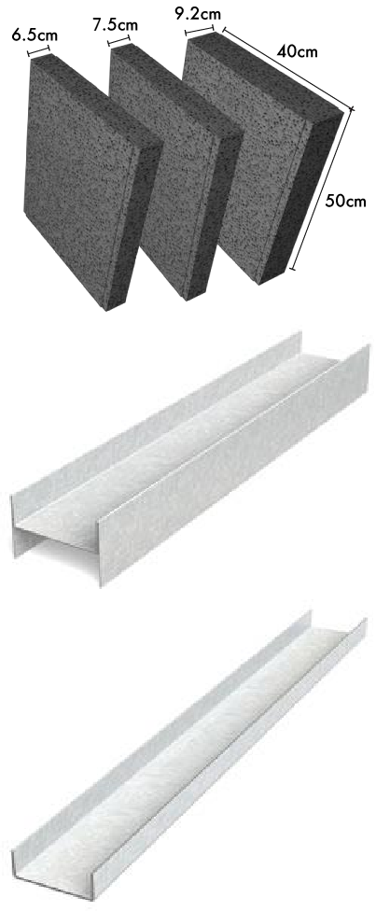
System Components
Product | Description
AH Insulation Lightweight Block (AH BLOCK™)
400 x 500 x 65mm thick or 75mm thick or 92mm thick
Hot-dipped Galvanised H-channel
Compatible to AH Block thickness. Used as wall studs.
Hot-dipped Galvanised U-channel
Compatible to AH Block thickness. Used as wall top / bottom runners / tracks.
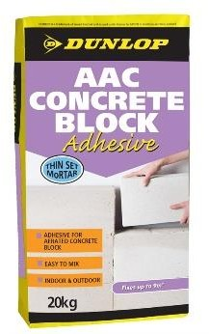 | Optional:  Dry Mix Adhesive  Used for gluing the blocks together at vertical and horizontal joints
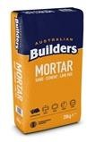 | Optional:  Mortar Mix  Used as mortar filling at vertical and horizontal joints

Product | Description
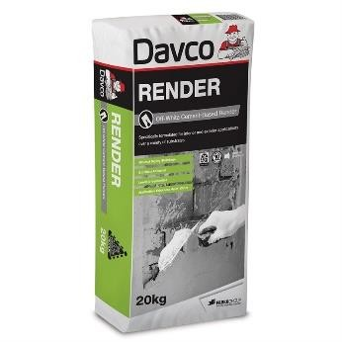 | Optional:  Cement-Based Render  Used as a preparation coat to level surface providing an even true surface. Also used to prepare minor chips or damage to blocks
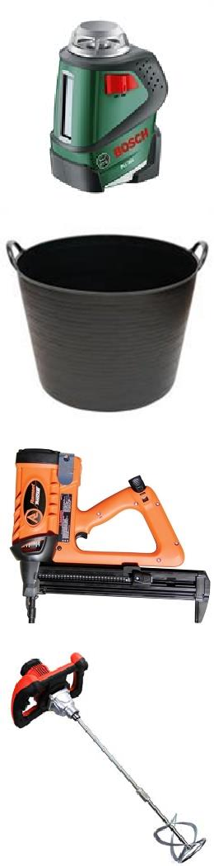
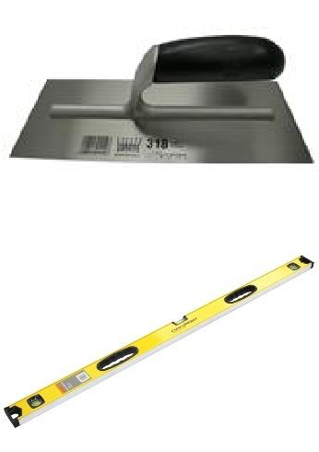

Tools / Equipment | Description
String Line / Laser Levels
Required to accurately set out and lay AH Block walls
Mixing Bucket
Required for mixing mortar, adhesive and render
Electric Drill or Ramset Tools
Required to drill or fasten and fix steel runners / rack in place
Stirrer
Can be fitted to electric drill to mix mortar, adhesive and render inside the mixing bucket
Trowels
Used to apply adhesive or mortar to block joints. It shall be applied with full and even coverage. May also be used for the installation of the render and texture coatings.
Spirit Level
Required to install the blocks level and plumb

Tools / Equipment | Description
Hand Saw
Used to cut AH Block to length and height
T-Square
Used to measure prior to cutting with hand saw
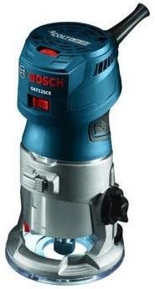 | Hand Router  May be used to chase services into AH Block walls
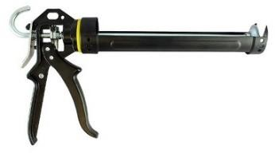 | Sealant Gun  Required to fill the control joins in the AH Block walls
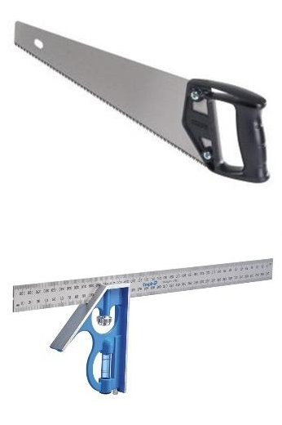

Construction Notes
A qualified person shall be engaged to prepare all design including specifications and drawing for any residential dwelling or commercial buildings, suitable for submission to and approval by the relevant authorities. No work shall commence until de sign is approved and deemed to comply with all statutory requirements including but not limited to licensing, environmental management plan, signage on site, Safe Working Method Statement (SWMS) and the like.

These notes and details shall be read in conjunction with the project’s contract documentation. Other notes to be considered:
  - Refer to architectural drawings for all setting out dimensions and ensure all starting lines and levels are marked out as per engineering drawing.
  - Should any omission, penetration, cutting of panels, discrepancy or fault exist, contact the project engineer immediately to review the design and for a decision before proceeding with work.

  - ISOTEC accepts no responsibility for the design or selection of supporting walls, lintels, beams, columns or other structural members. Nor any design for temporary restraint of walls.
  - Corrosion protection of all structural steelworks shall be specified by the project engineer or architect.

Work, Health, Safety & Personal Protective Equipment (PPE)
All works shall be carried out in accordance with Work, Health & Safety (WHS) Act including the wearing of PPE. Gloves and suitable clothing recommended while handling AH Blocks, to reduce abrasion and irritation of the skin as AH Block may have loose particles which may irritate the skin, resulting in itching. Approved respirators and eye protection should be worn at all times when cutting and chasing.

Delivery & Storage
AH Block boxes should be moved and handled with care and it is good practice to check the delivery for any damaged blocks. The boxes should be unloaded and stored as close to the intended installation area as possible. Unnecessary handling will increase the risk of damage to the blocks.
Care should be taken when cutting the packaging wraps or straps, goods may come away and cause injury or become damaged.
Tip: when a block is damaged it may be possible to cut away the damaged section and use the remaining portion in the wall.
All materials must be kept dry and preferably stored undercover. AH Block should be left in their boxes until they are required. Place the boxes on a level and stable surface. The project engineer should be consulted as to the adequacy of the structure to support AH Block if they not stored directly on the ground or concrete slab.

Construction (Typical)

Preparatory Works

Proper setting out, dimensional control, sufficient structural support for mechanical and electrical services, openings, together with surface preparation are critical in ensuring drywall sturdiness and quality. The approved design drawings and documentation should dictate the setting out and dimensional control. Also govern the performance and technical requirement of relevant system, standards as well as installation procedures. NOTE: Drywall here means non-loadbearing partition wall installed with AH Block and its steel frames, finished with plasterboard or similar materials.

Approved Drawings

An approved design drawing should ideally include profiles, sizes, connection details, reinforcing anchorage, sizes and types of fasteners and accessories. Dry-lining details in fire-rated wall, soffit and ceiling assemblies should also be indicated in the approved shop drawings where necessary.

Work Sequence | Good Practices
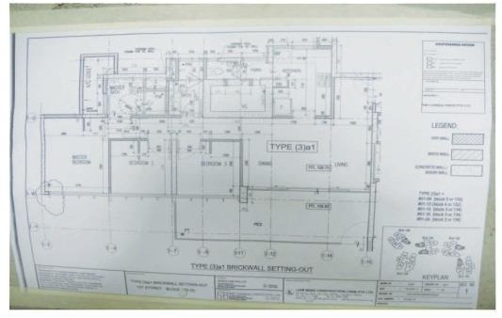 | a. Setting of reference gridline and setting out in accordance to approved design drawings / documentation.

Contact Surface Preparation For Installation Of Dry Wall

Contact surface for drywall installation preparatory works usually refers to end wall or column, soffit of slab and floor slab. Verticality of the end wall or column needs to be checked prior to receiving the starter stud. The evenness of the soffit of slab governs the securing of the top tracks/runners. The floor slab or kerb level and alignment dictates the stability of the bottom tracks/runners. All contact surfaces should be properly cleaned b efore setting out.

Work Sequence | Good Practices
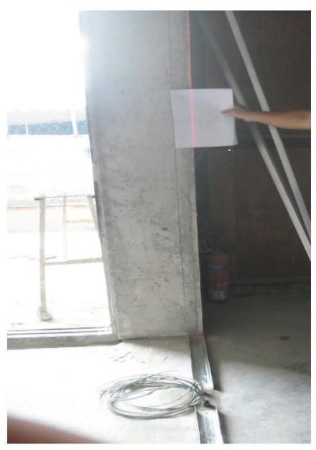 | a. Verticality of end wall / column must be checked and rectified prior to installation of the starter stud.

Work Sequence | Good Practices
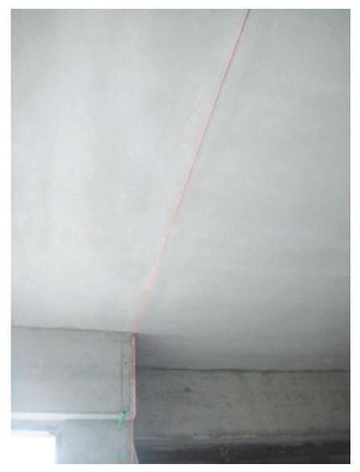 | b. Evenness of soffit slab must be checked and rectified prior to the installation of the top tracks / runners.
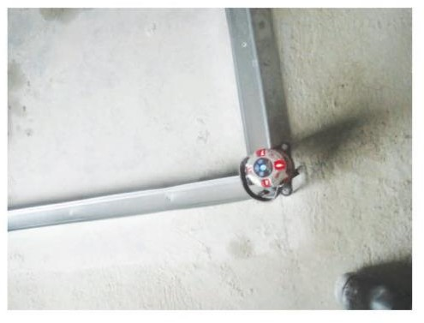 | c. For drywall without kerb:  Floor slab should be level and evenness to be rectified prior to the installation of the bottom track / runner.
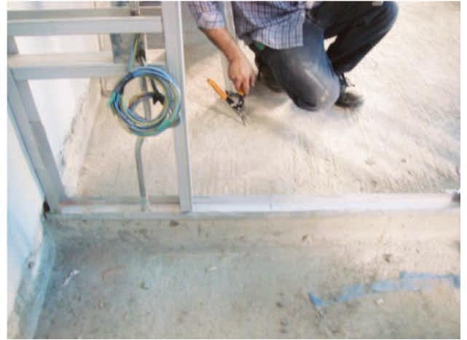 | - For drywall with kerb:  Kerb should be provided at wet areas. Maintain kerb evenness to achieve drywall frame stability.  - Straightness of kerb is important to ensure a good alignment of the partition wall.

Setting Out Preparation

The setting out preparation can begin once all approved design drawings and documentations are in order. Gridlines and levels are to be marked out on the end wall or column, soffit slab, and floor slab or kerb before installation works.

Work Sequence | Good Practices
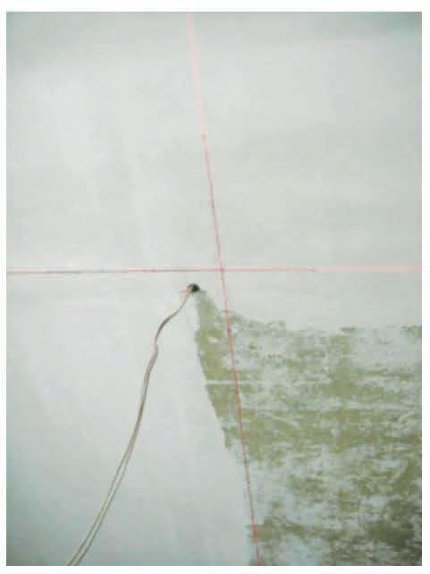 | a. Drywall starting line marked out on slab soffit as per approved design drawings or documentation.
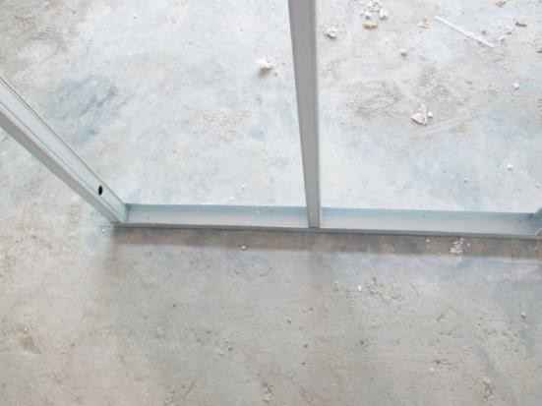 | b. Drywall starting line marked out on floor slab as per approved design drawings or documentation.
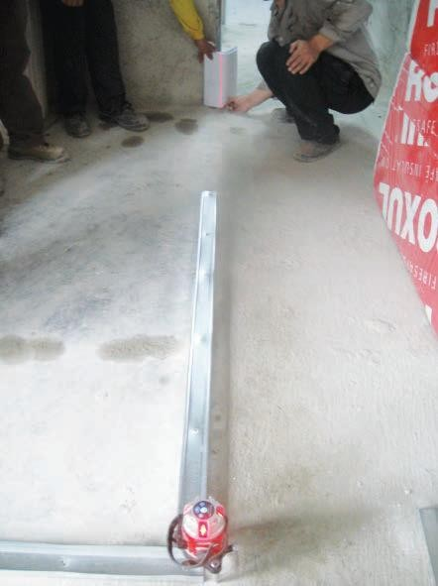 | c. Drywall starting line marked out on end wall or column as per approved design drawings or documentation.

Work Sequence | Good Practices
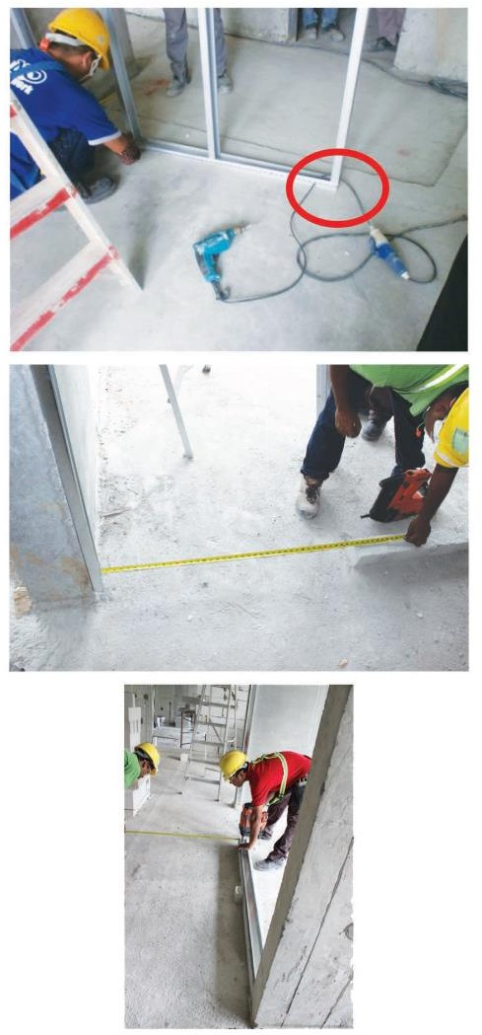 | d. Door opening marked out on floor slab as per approved design drawings or documentation.

AH Block™ System Installation Method

It is essential to identify the proposed location of openings, mechanical and electrical (M&E) services, and other fixtures before the installation of AH Block non -loadbearing drywall system. The setting out of the framing system, openings and additional supports are critical contributors toward the functionality of the AH Block wall integrity. Sequence of board installation, proper infill and other insulation material installation, and treatment material compatibility are also important to achieving quality work. All site work should be carried out in a safe manner to comply with BCA requirements and WHS Act.

Framing Works

Framing works form the structural component of the AH Block system. It is also critical towards fulfilling its functionality as a non-loadbearing wall. This section highlights the sequence of the framing installation process and the recommended best practices to achieve quality work.

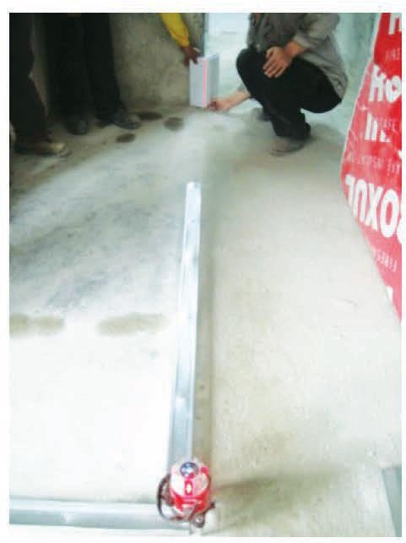
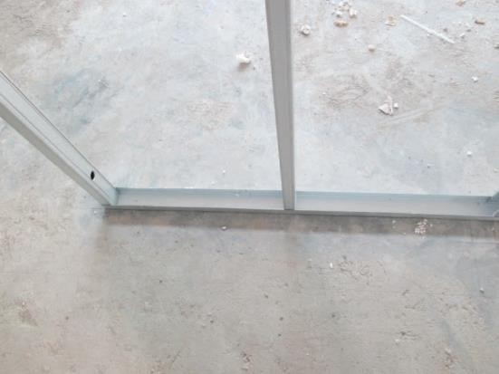
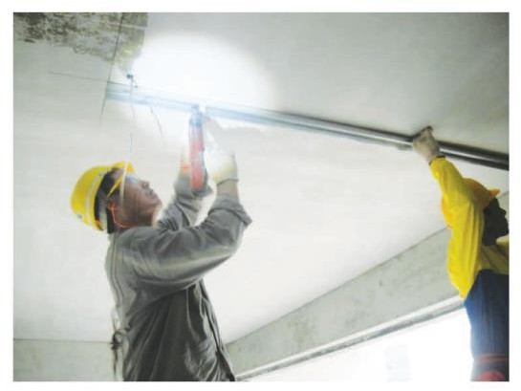
Work Sequence Good Practices

      - Mark out the starting line a. Ensure starting lines and levels are as per approved construction drawings by project engineer.
- Starting line should be marked on end wall or column, slab soffit and floor slab using sting lines or laser levels.
- Opening locations should be identified and marked out.

      - Install bottom track a. Floor is to be levelled before installing the bottom track.
- Tracks should be fastened to structural elements by using anchor bolt or fastener.
- Use mechanical fixing tools to fix U-channel galvanised steel track / runner to floor slab. Air or ramset equipment are ideal for this task.
- Joints in the tracks shall be butt jointed.

      - Install top track a. Ceiling is to be levelled before installing the U-channel galvanised steel top track / runner.
- Tracks should be fastened to structural elements by using anchor bolt or fastener.
- Joints in the tracks shall be butt jointed.
- Joints in the tracks must be covered with joint tape prior to skim coat.

Work Sequence | Good Practices
4. Install starter stud  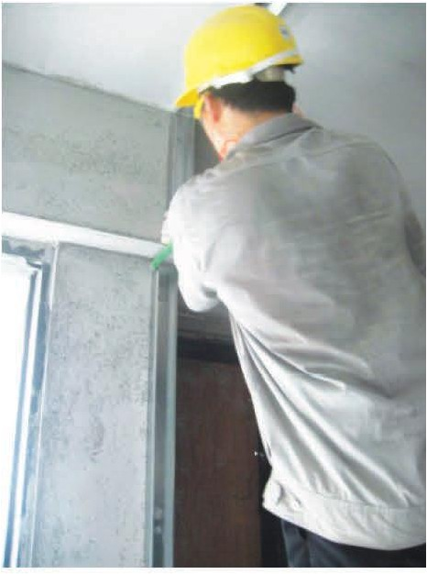 | - Ensure verticality of the end wall use a spirit level or laser marker.  - Gap to be allocated at top track to allow for deflection of top slab.  - Place studs in direct contact with doors frame jambs, abutting partitions, partition corners/edges, and existing construction elements.  - Check overall verticality of studs.

Wall Opening

The most common openings on drywall are for doors. Such openings re usually reinforced by the introduction of box stud to stiffen the opening.

Work Sequence | Good Practices
1. Install starter stud | a. Fix all started studs as per approved design drawings or documentation.
2. Install metal box studs to secure door frame | a. Secure the door frame, form a metal box stud to fix into back of starter stud.
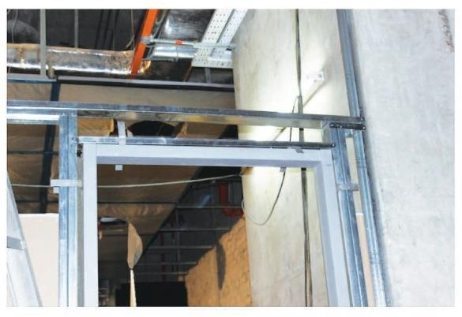

Work Sequence | Good Practices
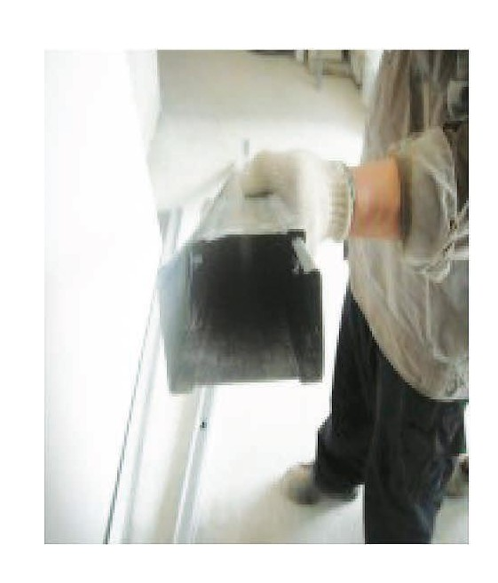
3. Install metal bracing above door frame to secure it  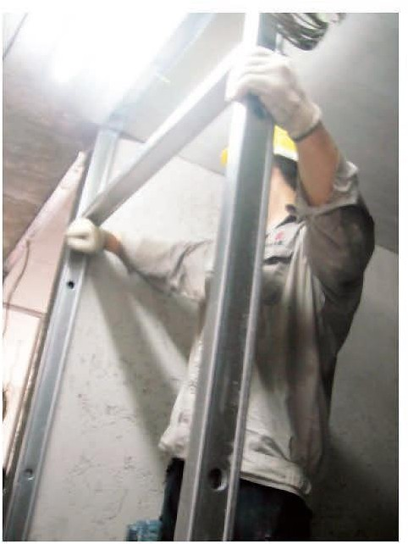 | a. Metal bracing or door head trimmer must be installed for door opening.
4. Alternative stiffener for door  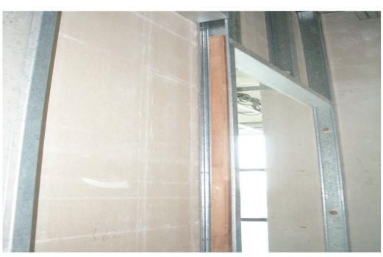 | a. Alternatively, a rectangular hollow section or timber with the same width as the stud can be placed and properly secured.

Additional Supports for M&E Services and Other Fixtures (if necessary)

Additional supports in the drywall may be required for fixtures such as electrical switches . Spacing of vertical studs and/or bracing to be adjusted accordingly to ac commodate the size and weight of fixtures. All fixtures should be identified and indicated in approved design drawin gs or documentation. Any additional supports should be duly designed and approved by the project engineer.

Work Sequence | Good Practices
1. Additional support for M&E Services  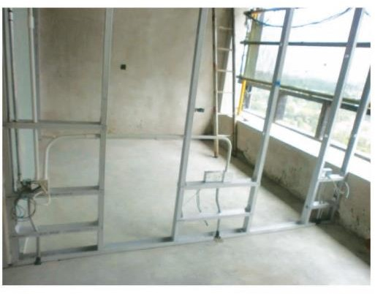 | - Identify location and type of M&E services.  - Identify penetration for wiring and conduits.  - Install metal bracing as necessary – to withstand the imposed load.

AH Block™ Installation

It is essential to identify the proposed location of openings, mechanical and electrical (M&E) services, and other fixtures before the installation of AH Block non -loadbearing drywall system. The setting out of the framing system, openings and additional s upports are critical contributors toward the functionality of the AH Block wall integrity as illustrated above

Work Sequence | Good Practices
1. Install AH Blocks | - Remove block from box and position the block vertically to the starter stud and horizontally on the bottom track / runner. Gently tap the block to fully close all gaps.  - (Optional. Recommended for wall height over 3m) Blocks can be bonded using cement-based mortar or grout. Mix mortar according to the directions on the packaging. Lay mortar level and plumb. Full coverage with approximately 3mm final joint thickness. Accurately place and tap block in place. Ensure that the block is level in all places. Alternatively, mix adhesive and apply to all joints. All loose particles and dust must be brushed from the joint surface before applying adhesive.  - Position the next block vertically adjacent (on top) the first block. Place the block
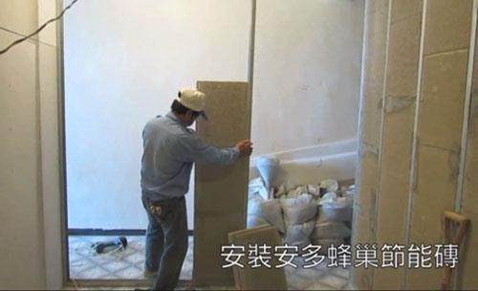

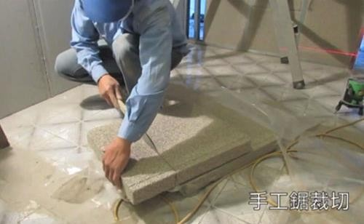

Work Sequence | Good Practices
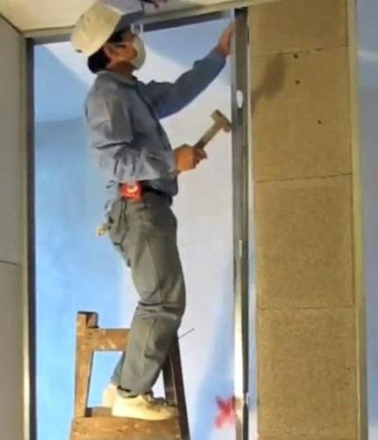  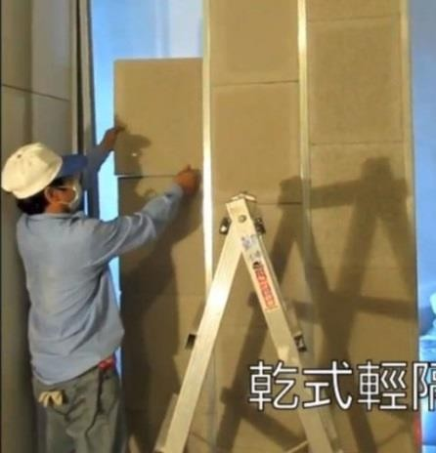 | down into position and gently tap the block  to fully close the joint. Repeat these steps.  - Once the block reaches the top rack, install the subsequent galvanised steel H-channel studs vertically adjacent to the blocks. Gently tap the stud into position until fasten. No mechanical fixing required.  - Blocks can be cut using handsaw to fit into space or remaining portion in the wall.  - Repeat the above until the wall is complete.
2. To incorporate M&E concealed services  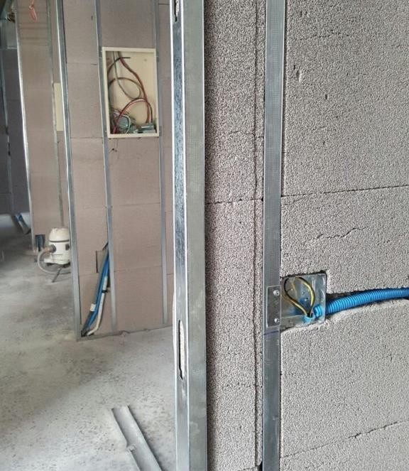 | a. Ensure all M&E concealed services are within the block, mark out and chase services route with grinder or hand router.

Work Sequence | Good Practices
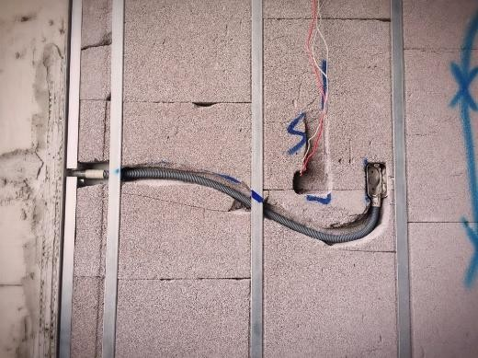
3. Filling  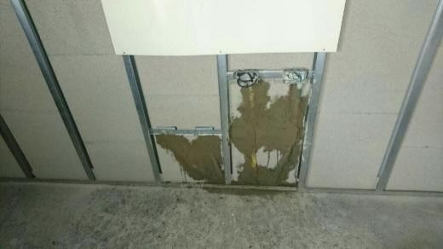  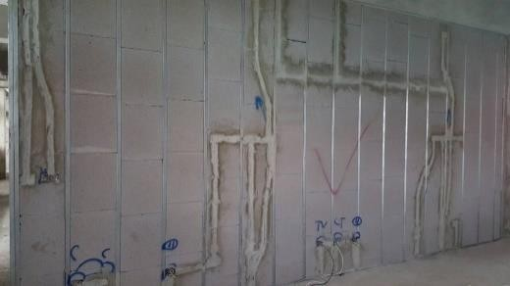 | - Mix mortar according to instructions on the product packaging.  - Ensure holes and chips on blocks are filled with mortar.  - Allow mortar to fully cure.  - Once completed the wall can be drywalled (recommended finish), cement rendered or skim coated and painted with masonry paint.

Drywall Board Installation / Wall Cladding

The board dimension and type of board layout is dependent on the overall framing installation. Builders, architects or project engineers should identify the board dimension and layout prior to any material order.

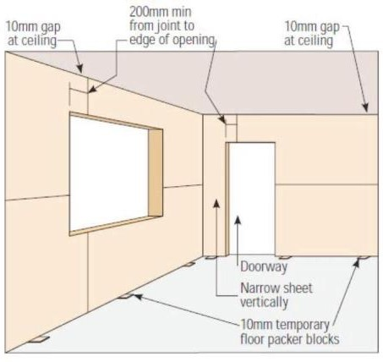
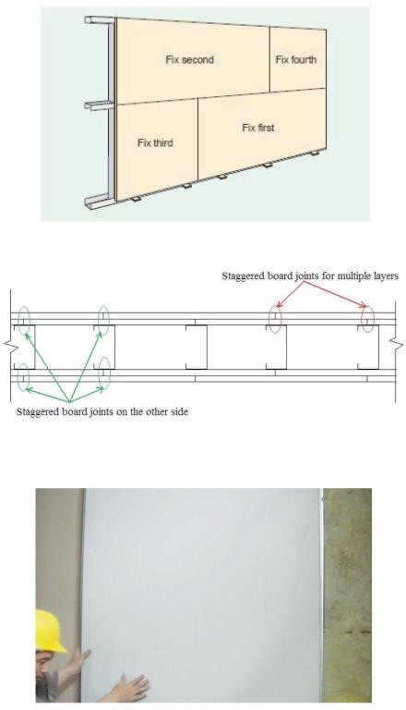
Work Sequence Good Practices

      - Typical board sizes a. Identify and calculate area and layout of board to
be installed.
b. Board dimension to be in accordance to frame spacing and layout.

1.1 Cutting of Boards a. Use proper tools such as T-square and handsaw or cutting knife to cut the boards or as per manufacturer’s specifications.

      - Sequence of horizontal board installation
- Ensure horizontal board installation sequence is as per manufacturer’s specifications:
- Install panels in such a manner that panel joints do not align with edge of opening.
- For multi-layered boards, stagger joints between the layers, as well as on opposite sides of partitions.
- Tightly butt tapered end board edge joints.
- For vertical board installation, start centre and place smaller boards at sides or edge.

Work Sequence | Good Practices
2.1 Securing of board  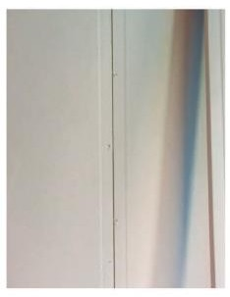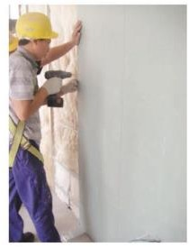  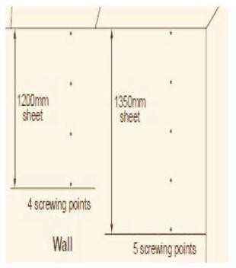 | - All butt joint screws are to be staggered.  - Plasterboard screws should be spaced:  - <300mm for butt joints  - <200mm for angles joints  - 10 to 16mm from edges and ends of plasterboard sheets  - Ensure the board is properly secured onto the vertical stud and does not cause any tilting of flange. Application of dry walls crews shall begin from centre outwards.  - Install screws from ends and edges of panels, and on centre along abutting end joints; and, on centre within the field of the panel.  - Panels shall not be fastened directly to the top and bottom runners to allow for top slab deflection movement
3. Sequence of screwing the board onto the vertical stud  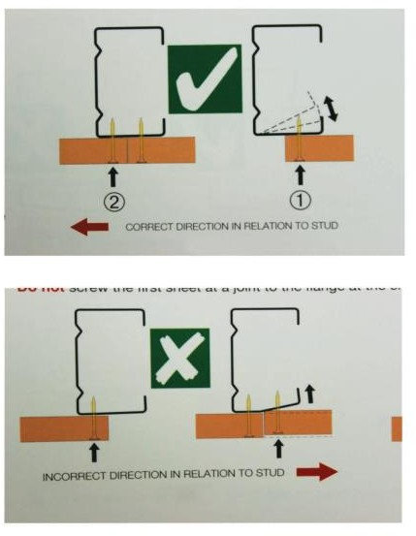 | - Apply the screws from the leg of top and bottom runners, onto the vertical studs for attachment of the panel.  - Proper sequence of board screwing i.e. correct direction, to the stud to prevent gap between board and stud.
4. Infill and sealant  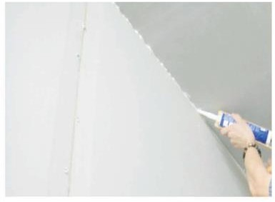 | - Proper installation of infill material typically helps to provide necessary fire resistance and sufficient acoustic insulation.  - Seal / caulk all perimeter gap of the wall frame with relevant and good quality flexible sealant material. Install as per manufacturer’s specifications.

Joint Treatment (Typical)

The last installation procedure for using board finishing is the treatment to various types of joints, edges and corners. Fire rated or acoustic sealant, corner beads, joint tapes, jointing compound and topping compound are common materials used. Examples shows the common types of treatment and the recommended good practices to achieve quality work.

Work Sequence | Good Practices
1. General requirement | - Proper enclosure of work areas prior to installation will reduce the impact of environmental changes e.g. fluctuations in temperature, humidity, airflow etc.  - Good planning prior to hanging panels / boards can eliminate unnecessary joints.
2. Fire Rated and Acoustic sealant  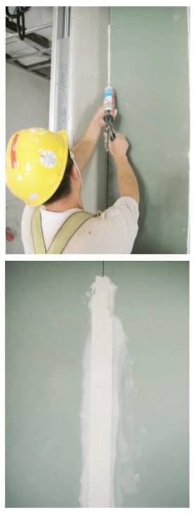 | a. Apply fire rated or acoustic sealant as stated in approved shop drawings or manufacturer’s specifications. Properly seal perimeters, openings in wall and ceilings.
3. External corner bead  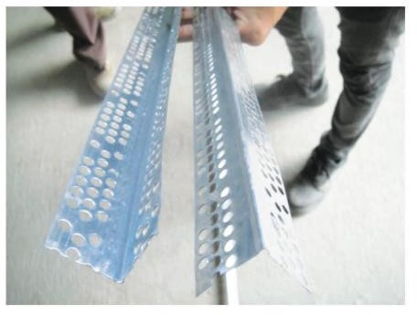 | - Use of external corner bead enables visually straight joint, better corner alignment and neater finishing.  - Also, functions as a protection against edge damage.

3.1 Fixing of external angle  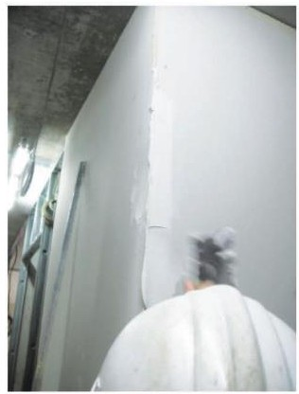  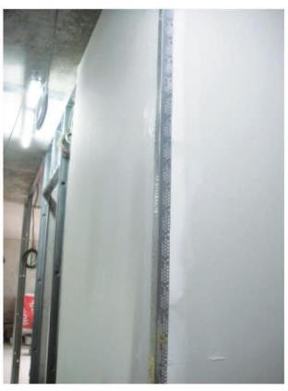  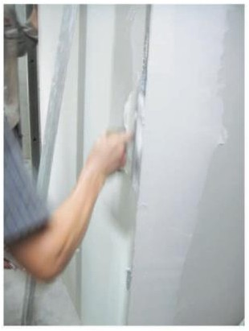 | - Apply a coat of joint compound before placing external angle.  - Ensure verticality of external angle.  - Ensure the final treatment to the external angle by applying three coats of joint compound at stipulated intervals as specified in the approved shop drawings or manufacturer’s specifications.
3.2 Three coats for all joint treatment  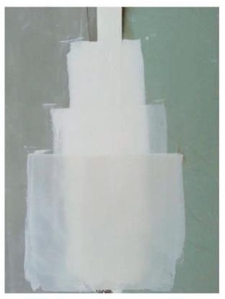 | - Provide proper treatment to interfacing and butt joints by applying three coats of joint compound at stipulated intervals as specified in the approved shop drawings or manufacturer’s specifications.  - Here is an example of the application of three coats of joint compound for different surface interfacing treatment.  - Ensure the final treatment to the external angle by applying three coats of joint compound at stipulated intervals as specified in the approved shop drawings or manufacturer’s specifications.

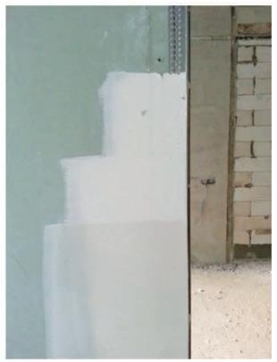 | d. Here is an example of the application of three coats of joint compound for external angle treatment.
4. Control joint component  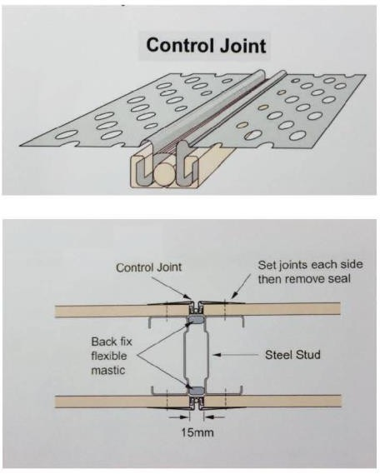 | - Control joint to be provided:  - in long continuous walls at 12 m maximum centers;  - for panels of different materials.  - Fasten the control joint to the panels / boards at a maximum of 150mm centres.
5. Jointing tape / Mesh tape  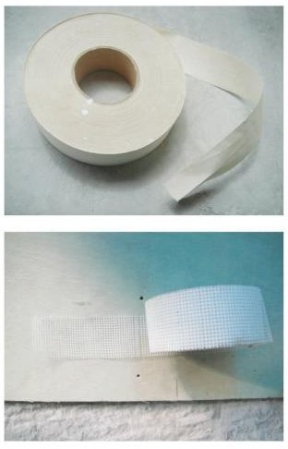 | - Proper use of jointing tape as per approved design drawings or manufacturer’s specifications.  - Jointing tape is used for reinforcement of panels / board recessed joints, internal angles, surface fractures and repairs to internal walls.  - Use of internal corner taping tool for internal corner.
6. Joint compound | - Mix proportion to be in accordance to the manufacturer’s instruction.  - Ensure that compound is used within the stipulated working time as recommended by the supplier.

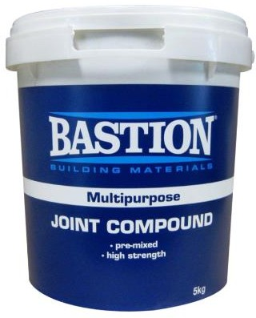 | - Allow sufficient curing and dry time before sanding and finishing.  - Mixing joint compound in clean buckets reduces probability of lumps forming, scratches and harden of material.  - Flush and clean compounds from equipment, and brush before the setting action takes place.

Fixing Items to Drywall

Hanging objects on drywall requires proper fasteners and knowledge of installation and type of wall material. It Is a good practice for the builder, project engineer, designers or architects to work with the drywall supplier to prepare a manual or specific ation on how to fix items on the drywall. The correct fixing method depends on the weight of the fixtures used.

It is advisable to refer to the drywall manufacturer’s recommendations for the types of anchors to be used for fixing / hanging items onto the drywall.

Description | Good Practices
Wall Anchorage | Wall anchorages can be generally classified into 2 main categories, namely:  - Light to medium duty anchor (approximately up to 12 kg per point load); and  - Heavy duty anchor (approximately 20 kg per point load).
Light Weight Fixtures | Light weight fixtures such as pictures frame, small mirrors, light shelves, lamps, tools, sports equipment, etc. can be fixed with simple screw or expandable plastic screw anchor directly on the board drywall.
Medium Weight Fixtures | For medium weight objects such as big mirror, large picture frame or medium size shelve, etc. of up to 12 kg, stronger types of anchorage fitting may be required. It is important the weight of the fixture should not exceed the weight rating of the anchorage. The weight limits of the anchorage should be labelled on the product packaging.
Heavy Weight Fixtures | For heavy items such as television, wall cabinet or other wall attachments of up to 25kg, it is recommended that such fixing be installed by trained skilled personnel. For such heavy fixtures, the anchors are usually fastened onto the steel studs frame. The number and types of anchors used will be determined by the weight and usage of the fixtures.

Wall Detailing (Typical)

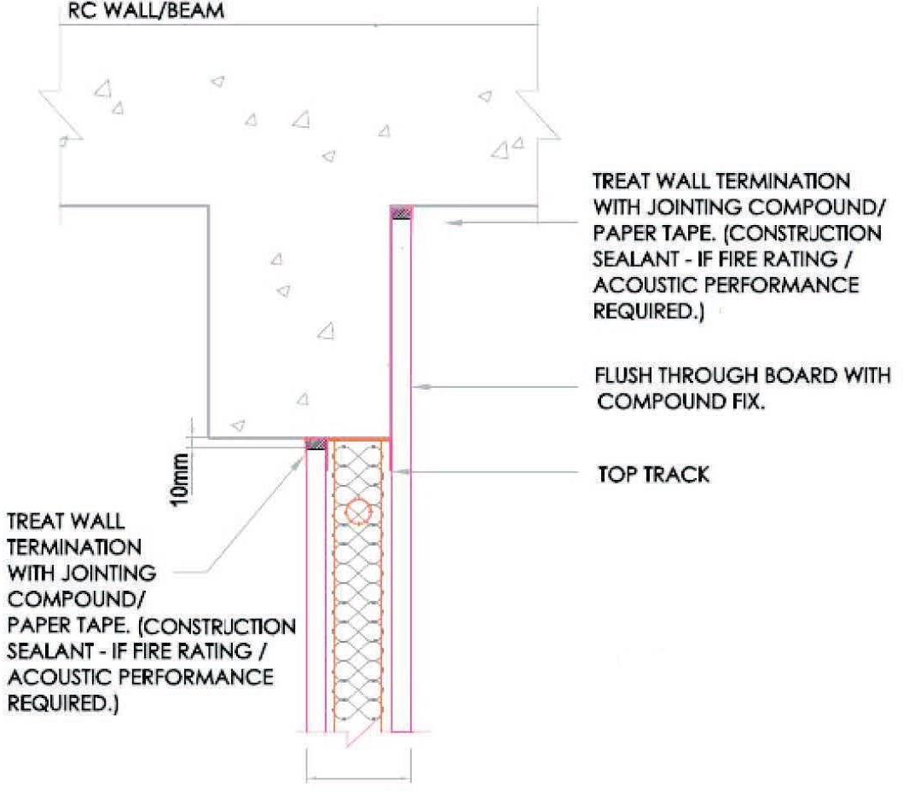
Proper construction detailing is usually recommended by board manufacturer or as identified in the approved design drawings or documentations.

Typical Wall Detailing
Drywall and RC wall/beam joint detail

Drywall and ceiling slab joint detail
Drywall and floor slab joint detail
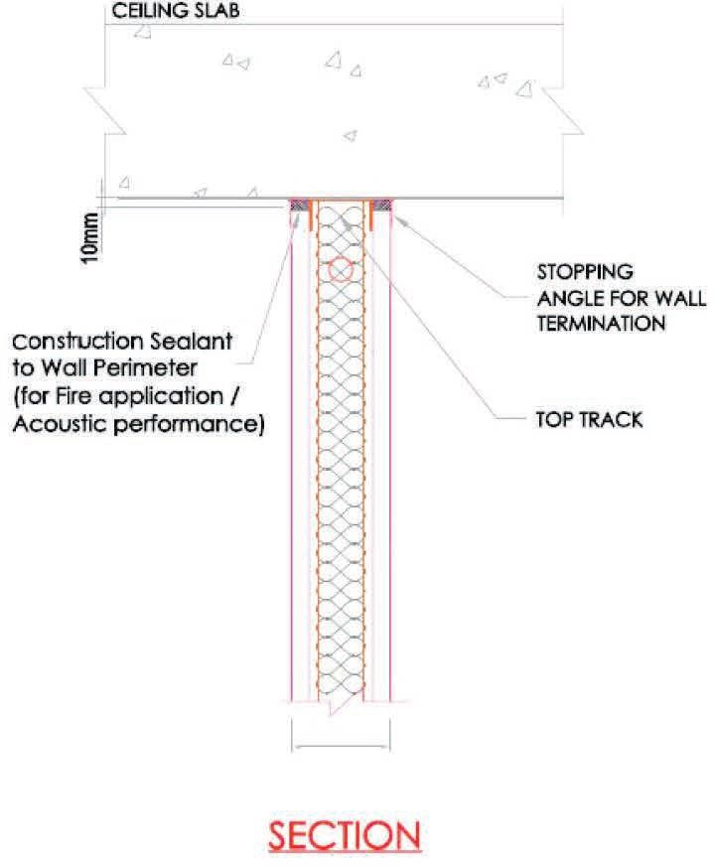
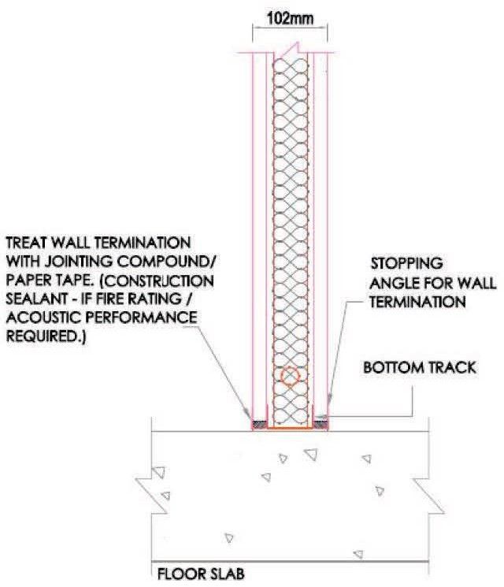

Drywall and wall joint detail
Drywall intersection joint detail
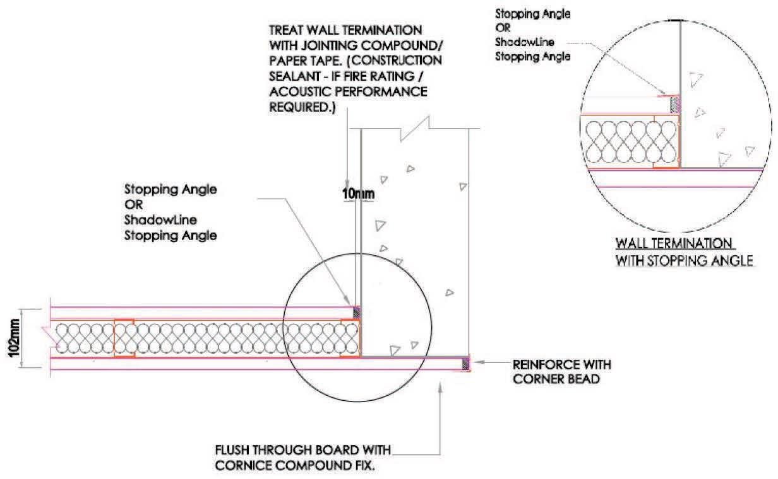
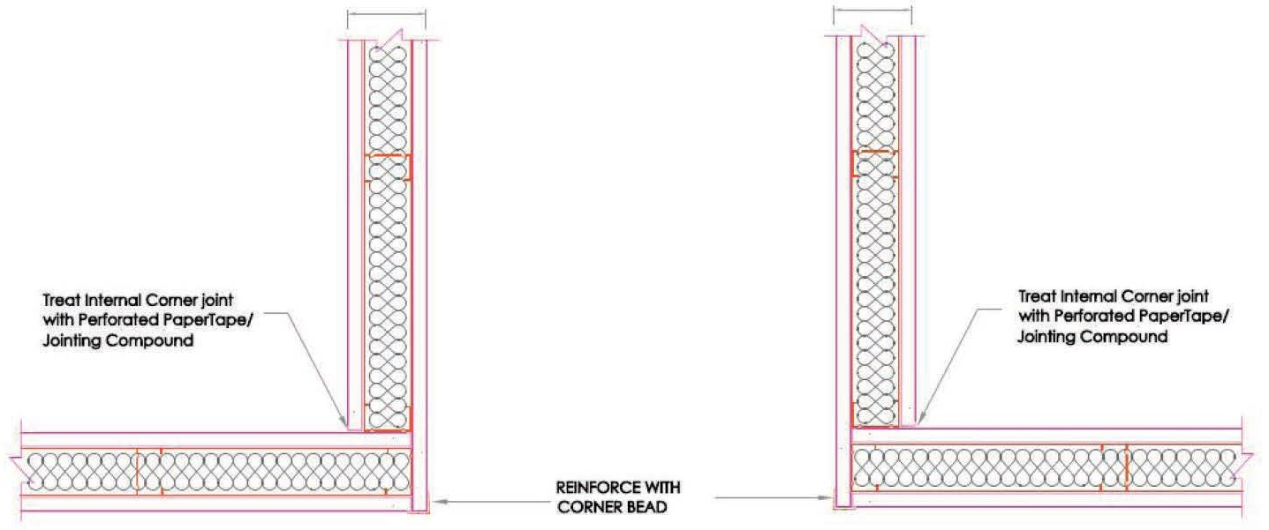

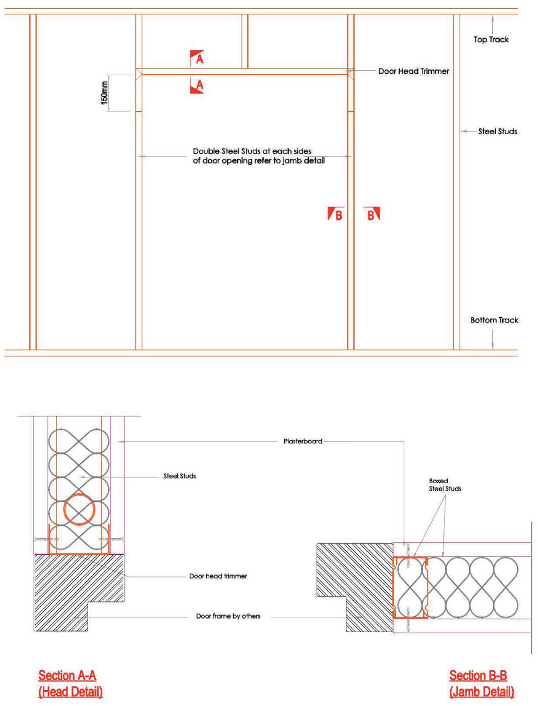
Door opening and section

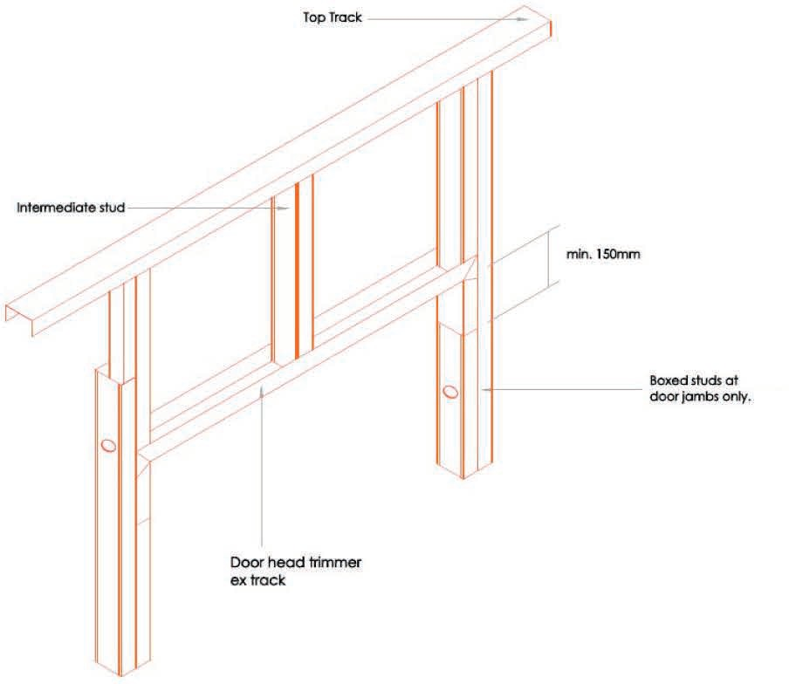
Door head trimmer detail

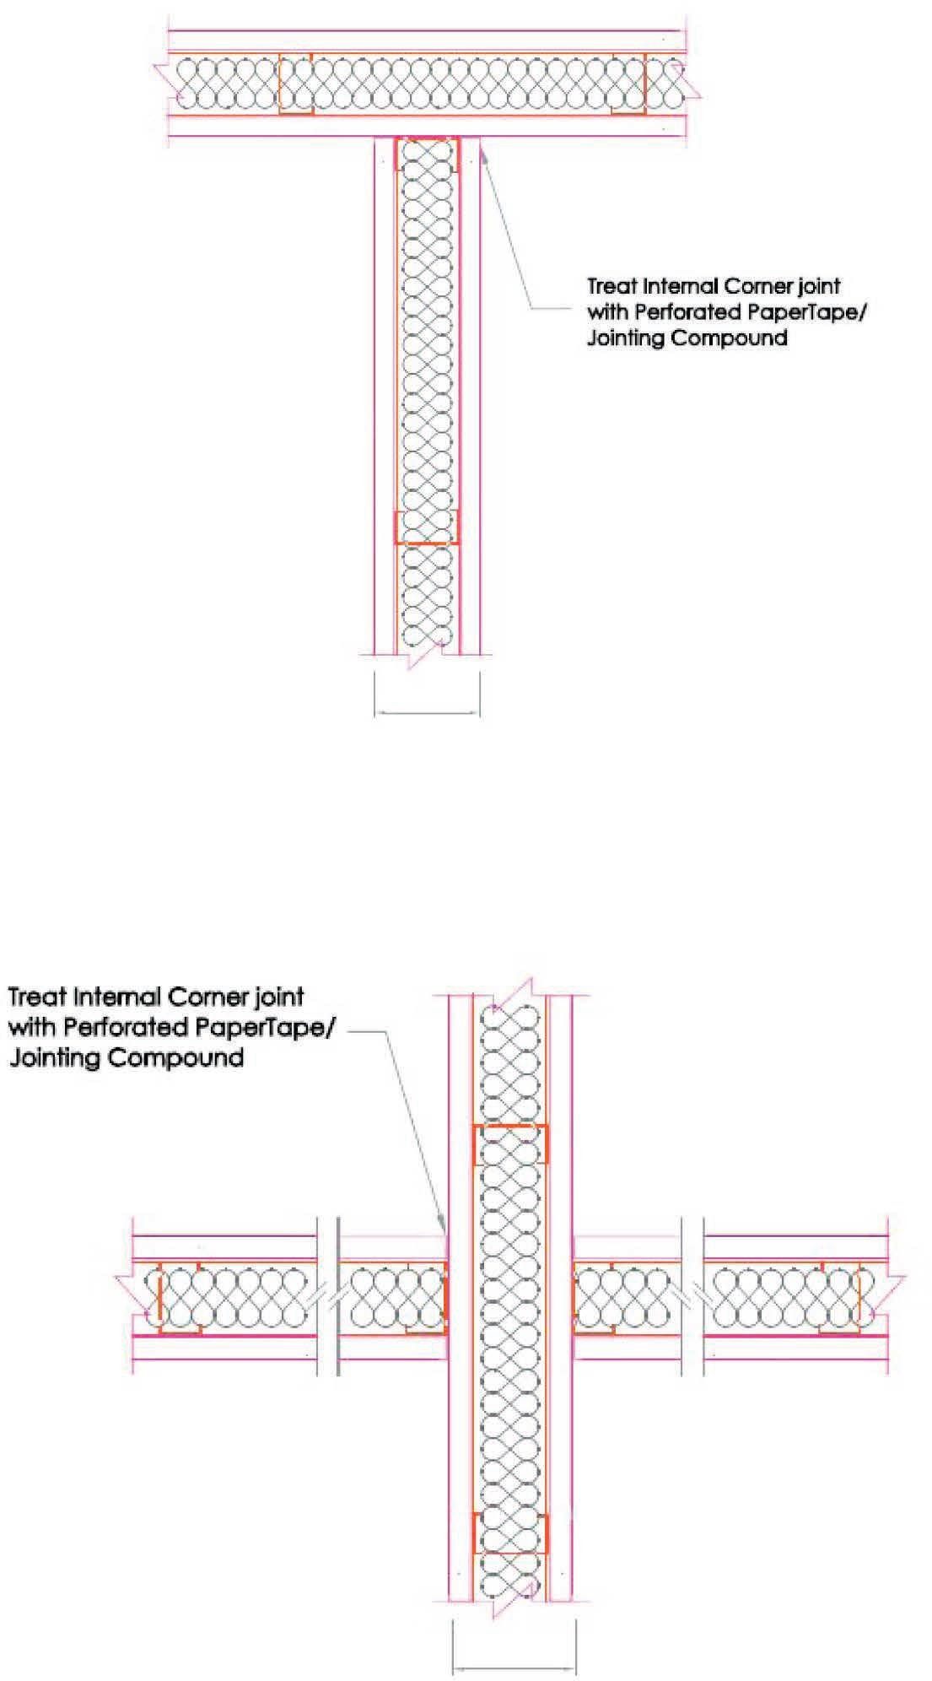
Drywall intersections detail

IN ACCORDANCE TO TUV SUD PSB PTE LTD FOLLOWING TEST REPORTS.

BS476 PART 22 - 7191137019-MEC16/2-LJH DATED 22 JUN 2016 (2 Hours Fire Resistant)
BS476 PART 22 – 7191180454-MEC18-KKC DATED 02 MAR 2018 (4 Hours Fire Resistant)
BS5234 PART 2:1992 (OR SS492:2001) – 7191157237-MEC17-YX (Robust & Strength)

Appendix 1 – 92mm AH Block™ Wall System (Typical)
For reference only

35

400 400
Galvanised steel 94mm U-channel
top track

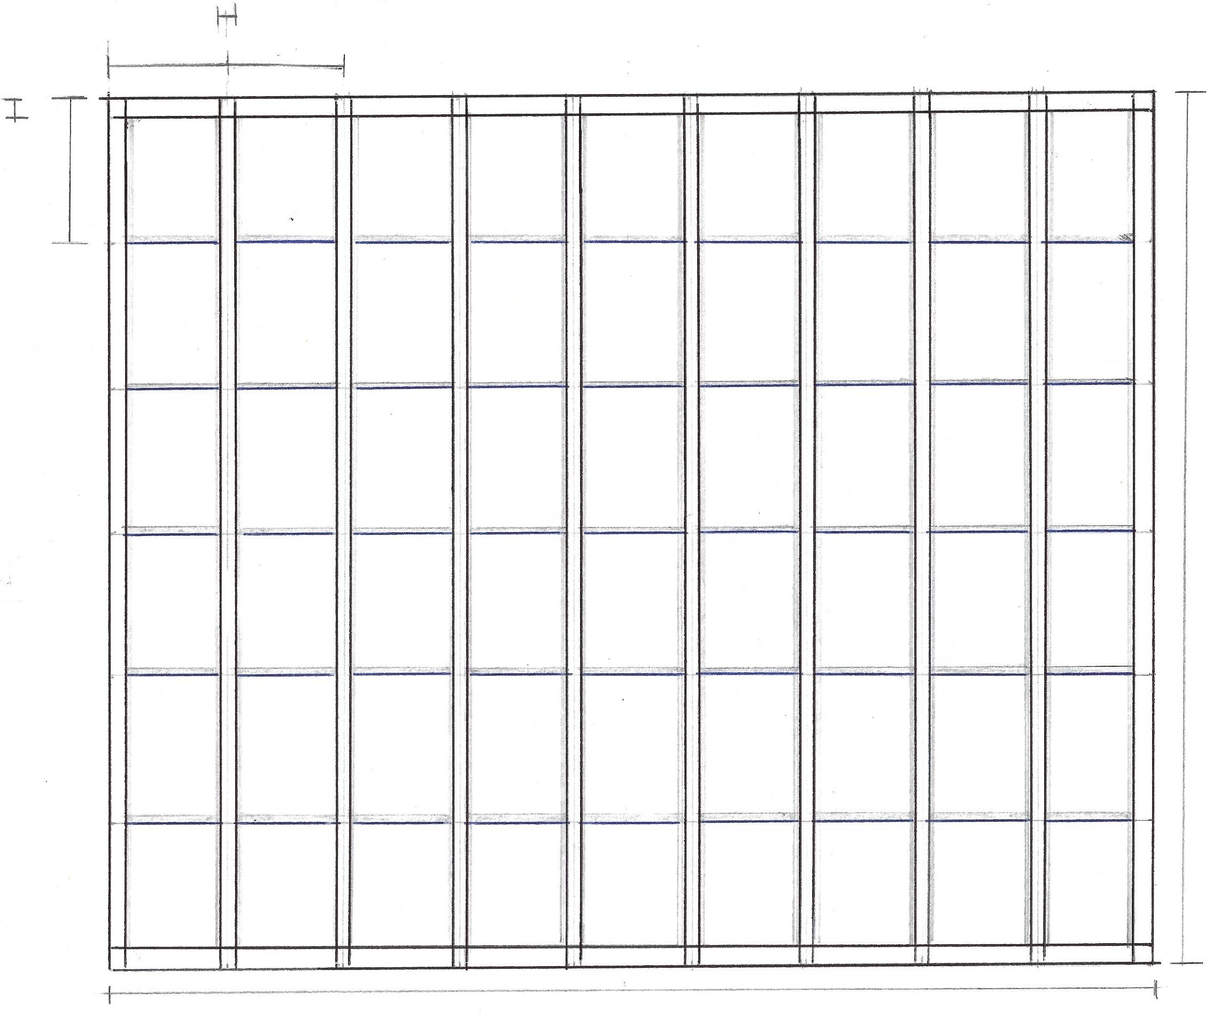

30

500

Galvanised steel 92mm H-channel vertical stud

Galvanised steel 94mm U-channel
starter stud
3000

AH Block™ 400 x 500 x 92mm thick

Galvanised steel 94mm U-channel bottom track
3600

1200 1200 1200

Fully seal all perimeter gaps and board joints with quality fire rated or
acoustic sealant

Proper treatment to interfacing joints as per builder’s recommendation

1800
600

2400

Plasterboard or decorative panels as per builder’s recommendation
1200

2400 1200

Galvanised steel 94mm U-channel
top track
Ceiling

Fully seal all perimeter gaps and board joints with quality fire rated or acoustic sealant

AH Block™
500 400 x 500 x 92mm thick

Plasterboard or decorative panel

Metal screw to securely fasten bottom track

AH Block™ 400 x 500 x 92mm thick
Galvanised steel 94mm U-channel bottom track

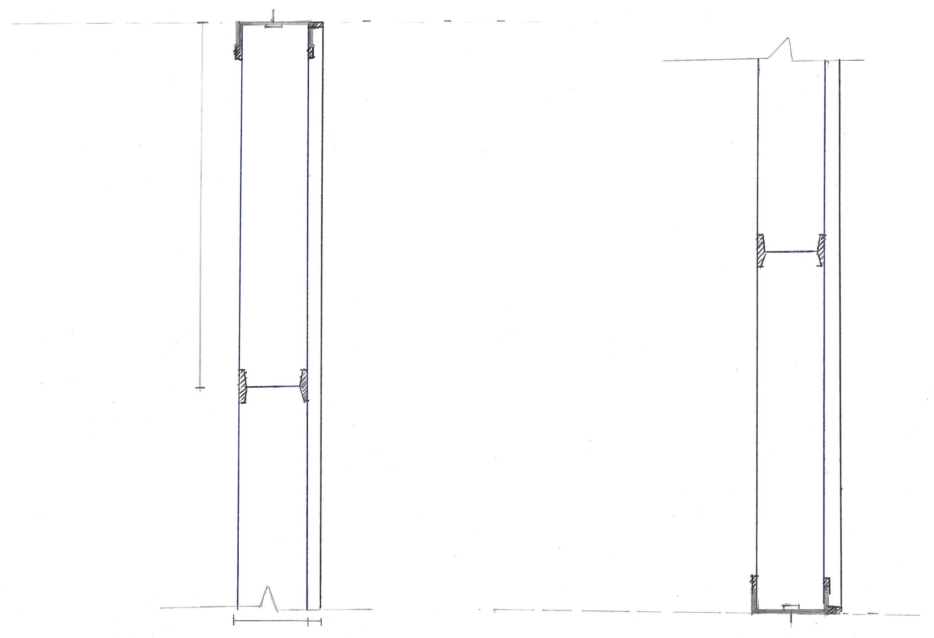

Floor

92 varies

Galvanised steel 94mm U-channel
starter stud

Galvanised steel 92mm H-channel vertical stud. No mechanical fixing is required to fasten stud.

400
Wall

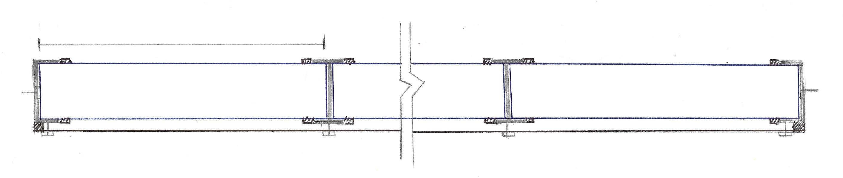
Fully seal all perimeter gaps and board joints with quality fire rated or acoustic sealant
Plasterboard or
decorative panel Plasterboard screws.
Install as per builder’s
recommendation.

AH Block™ 400 x 500 x 92mm thick

Metal screw to securely fasten starter or end stud

